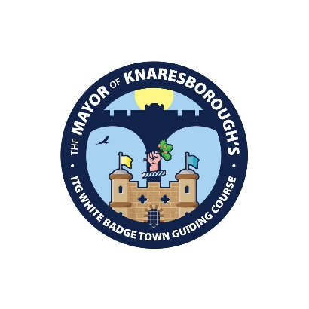
The Mayor of Knaresborough’s ITG White Badge Town Guiding Course

APPLICATION FORM
Please complete the sections below and read the data protection statement that explains why we need this data and how we will use it.
PERSONAL DETAILS

Full Name

Email

Home Number

Mobile Number
Address

Postcode
Emergency Contact (name and phone number)
First Language

The information requested below is vital to ensure that appropriate care and support is available for you during your volunteering activity. Please consult your family doctor if you are unsure about the suitability of the activity

Medical | Please make us aware of any medical conditions or allergies that you feel we need to know about
Access | Please make us aware of any access needs that you would like us to be aware of. This includes help with completing this application form or undertaking exams.

RELEVANT KNOWLEDGE, SKILLS AND EXPERIENCE (please submit additional sheet of paper if required)
Tell us about your interest in the History of Knaresborough and your connections (if any) to the area (maximum 100 words).

Personal statement. Please explain in NO MORE THAN 300 WORDS why you wish to apply for the ‘The Mayor of Knaresborough’s ITG White Badge Town Guiding Course’. Describe the qualities and characteristics which make you particularly suitable for guiding. Please include details of relevant experience (e.g. working with groups of people, public speaking, acting, teaching/lecturing etc.) and of any relevant specialist knowledge. Tell us about your communication skills and your ability to work both independently and as part of a team.

AVAILABILITY
THE PROGRAMME OFFERS A COMPREHENSIVE INTRODUCTION TO GUIDING AND WILL LEAD TO A PRACTICAL AND WRITTEN EXAMINATION. TO BE SUCCESSFUL, STUDENTS WILL NEED TO SUPPLEMENT THIS WITH PRIVATE STUDY.

This programme is likely to require around 2-3 hours of private study each week, in addition to the training sessions. Are you able to commit to this level of private study? YES / NO

On successful completion of the course, would you be willing to be part of a rota of volunteers to lead a scheduled walking tour? YES / NO

Are you available for interview on Wednesday 13 November? Please indicate whether morning or afternoon is preferable

In addition to the training sessions on Wednesday (AM or PM or both on some dates) there is a compulsory full day communications seminar on Monday 24th February. Please confirm that you can attend this. It will not be possible to complete the course if you are unable to attend on this day

Data Protection Statement:
All of the information collected in this form is necessary and relevant to the performance of the volunteer position. We will use the information provided by you on this form to both give a duty of care to you and visitors and to complete reports to external funders. Your data will be shared with Love Yorkshire who are conducting tour training and the ITG who register all candidates. All parties will treat personal information with the utmost confidentiality and in line with current data protection legislation. We rely on the lawful basis of consent to process the information provided by you in this form.

We will use the information for administration of your volunteer position and in relation to any legal challenge which may be made regarding our practices.

For more information on how we use the information you have provided, please see our privacy notice which can be obtained by emailing community@knaresboroughtowncouncil.gov.uk
Declaration:
I consent to give my data for the use described above

Signed:

Date:

Mayor of Knaresborough’s Town Guides Data

Please return this form electronically to community@knaresboroughtowncouncil.gov.uk by 12:00 on Thursday 31st October. If you are unable to add an electronic signature we will ask you to sign a printed copy at interview.

